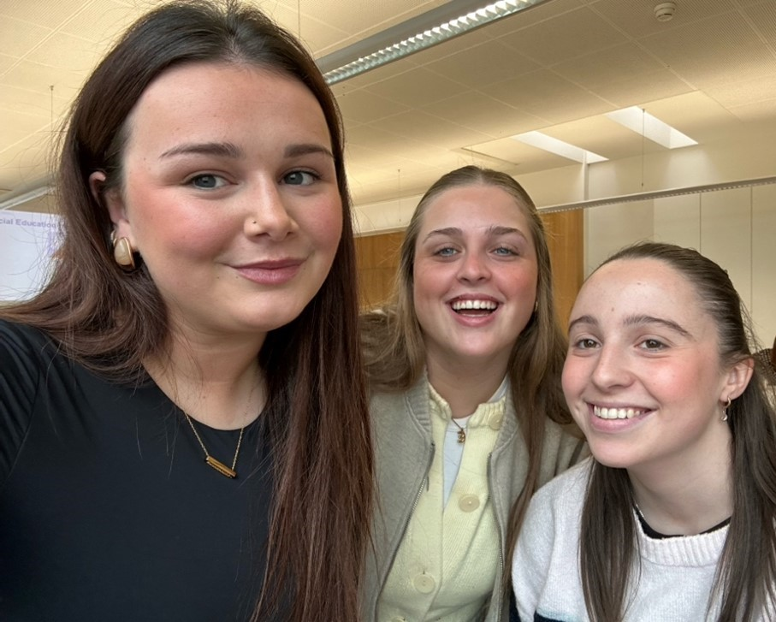

Emer’s questions

- How did your everyday life in Switzerland change from what you were used to in Ireland ?
- Was there any trip or experience you had on your stay that you remember ?

Charlotte’s questions

- How did you find the courses you took at PH Zug ?
- What was your favourite course ?

Ellen’s questions

- What is you favourite memory from your internship at IZL ?
- What did you get out of this experience and would you recommend it ?

